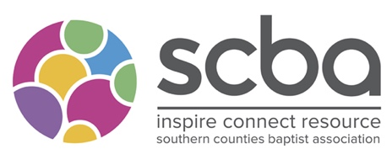
All Member Churches of the SCBA shall be entitled to nominate persons for election as a trustee.

Southern Counties Baptist Association: Trustee Application Form

In line with Safer Recruitment guidelines, we ask for application forms to be filled in prior to a name going to the Annual General Meeting. Information in this application will be used to propose your name to the SCBA AGM.

By submitting this form you are acknowledging that you do not know of any reason why you should not serve as a Charity Trustee.

Please return the form to Amy Allen, the association administrator, office.administrator@scba.org.uk

Full Name:
Address:

Church where you are a member:
Is your church willing to nominate you to be a trustee?
Contact Number:
Email:

Signature:

Can you tell us why you would like to become a trustee of the SCBA?

Could you tell us an overview of your Christian journey?

The following areas of knowledge, skills and expertise are all valuable to a trustee board. Please indicate any areas that you consider you bring to this role:

- Finance
- Fundraising
- Mission
- Children, Youth and Families Work
- Safeguarding
- Human Resources
- Networking
- Publicity
- Digital Media
- Pastoral Ministry
- Other, please specify:

What area of the mission/ministy of the SCBA are you interested in

References:
Please give the name and address of two referees that you have known for a minimum of two years (not a relative) include at least one church reference, who may be contacted by SCBA.
Please ask permission prior to submitting referees details and confirm full address.

Name (including title):

In what capacity do you know this person:
How long have you know them:
Address:

Phone Number:
Email:

Name (including title):

In what capacity do you know this person:
How long have you know them:
Address:

Phone Number:
Email:

