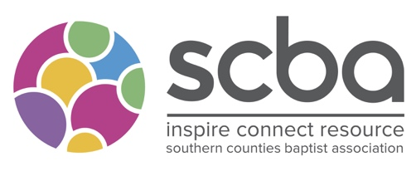
SCBA Sabbatical and CMD Grants

Please complete the form as fully as possible and send it with a heading of ‘SCBA Grant’ to office.administrator@scba.org.uk

We need a month’s notice to consider an application at a committee.
Your Name:
What Church are you part of the leadership team at?

What is your role?

Contact details –
Email

Phone

Is this application supported by your Regional Minister?
Name of Regional Minister
Amount Applying For?

In no more than 500 words can you tell us how this funding will enhance your study?

In what ways does this link with the purposes of the SCBA?

Is there anything about your study/sabbatical which is distinctively Baptist?

What other funding are you receiving?
What will happen if you don’t receive funding?

Name
Signature:
Date:

