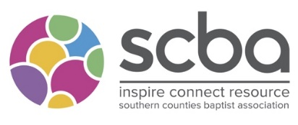
SCBA Mission Focus Grant

Please complete the form as fully as possible and send it with a heading of ‘SCBA Grant’ to office.administrator@scba.org.uk

We need a month’s notice to consider an application at a committee.

Name of Church
Address of Church

Website

Name of Minister or Missional Lead:
Contact details –
Email

Phone

Sponsoring Church or Partners (If applicable)
How much are you applying for?

In no more than 500 words can you tell us what is the objective of the mission/ ministry?

In what ways does your church / missional project link with the purposes of the SCBA?

Is there anything in the church/missional project which is distinctively Baptist?

What do you perceive to be the main outcome of the mission / work of the church? How will the grant enhance this?

What other funding are you receiving from other partners/grants?

What will happen if you don’t receive funding?

Name
Signature:
Date:

