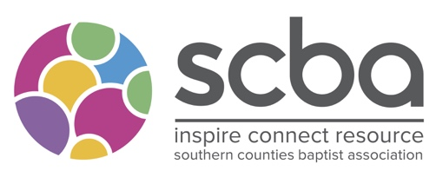
SCBA Sabbatical and CMD Grants

Please complete the form as fully as possible and send it with a heading of ‘SCBA Grant’ to office.administrator@scba.org.uk

We need a month’s notice to consider an application at a committee.
Your Name:
What Church are you part of the leadership team at?

What is your role?

Contact details –
Email

Phone

Is this application supported by your Regional Minister?
Name of Regional Minister
Amount Applying For?

In no more than 500 words can you tell us how this funding will enhance your study?

In what ways does this link with the purposes of the SCBA?

Is there anything about your study/sabbatical which is distinctively Baptist?

What other funding are you receiving?
What will happen if you don’t receive funding?

Name
Signature:
Date:

Appendix 1: Mission Focus Grant

Please complete the form as fully as possible and send it with a heading of ‘SCBA Grant’ to office.administrator@scba.org.uk
We need a month’s notice to consider an application at a committee.
Name of Church
Address of Church

Website

Name of Minister or Missional Lead:
Contact details –
Email

Phone

Sponsoring Church or Partners (If applicable)
How much are you applying for?

In no more than 500 words can you tell us what is the objective of the mission/ ministry?

In what ways does your church / missional project link with the purposes of the SCBA?

Is there anything in the church/missional project which is distinctively Baptist?

What do you perceive to be the main outcome of the mission / work of the church? How will the grant enhance this?

What other funding are you receiving from other partners/grants?

What will happen if you don’t receive funding?

Name
Signature:
Date:

Appendix 2: Sabbatical and CMD Grants

Please complete the form as fully as possible and send it with a heading of ‘SCBA Grant’ to office.administrator@scba.org.uk
We need a month’s notice to consider an application at a committee.

Your Name:
What Church are you part of the leadership team at?

What is your role?

Contact details –
Email

Phone

Is this application supported by your Regional Minister?
Name of Regional Minister
Amount Applying For?
In no more than 500 words can you tell us how this funding will enhance your study?

In what ways does this link with the purposes of the SCBA?

Is there anything about your study/sabbatical which is distinctively Baptist?

What other funding are you receiving?

What will happen if you don’t receive funding?

Name
Signature:
Date:

Appendix 3: Support Grant

Please complete the form as fully as possible and send it with a heading of ‘SCBA Grant’ to office.administrator@scba.org.uk
We need a month’s notice to consider an application at a committee.

Your Name:
Church you are a member of or where you attend?

Contact details –
Email

Phone

Is this application supported by your Minister/Church Leader
Name of Minister/Church Leader
Amount Applying For?
In no more than 500 words can you tell us how this funding will support you in your trip for Christian Service?

In what ways does this link with the purposes of the SCBA?

What other funding are you receiving?

What will happen if you don’t receive funding?

Name
Signature:
Date:

Appendix 4: Confidential Fund

Please complete the form as fully as possible and send it with a heading of ‘Confidential Fund’ to teamleaders@scba.org.uk

Name of person receiving support?
Name of Church where they are ministering /leading?

Contact details –
Email

Phone

Is this a self-referral?
Name of person referring?
Amount Applying For?
In no more than 500 words can you tell us how this funding will support you or the church minister/leader you are applying for?

Name
Signature:
Date:

